**EXPERIMENT NO. 3**

**AIM**

To familiarize DDL Commands- ALTER,DROP,TRUNCATE,RENAME

**Questions**

1.Create a table emp with attributes empno number(4)as primary key, ename char(10),hiredate,

salary,commission and insert the following 5 rows of data

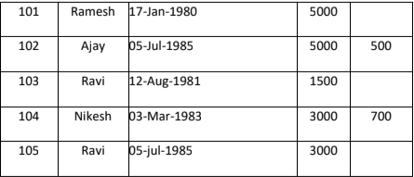

**ANSWERS**

create table Emp(empno int primary key,ename varchar(10),hiredate date,salary int,commission int);

insert into emp(empno,ename,hiredate,salary)values(101,"Ramesh","1980-01-17",5000);

insert into emp(empno,ename,hiredate,salary,commission)values(102,"Ajay","1985-07-05",5000,500);

insert into emp(empno,ename,hiredate,salary)values(103,"Ravi","1981-08-12",1500);

insert into emp(empno,ename,hiredate,salary,commission)values(104,"Nikesh","1983-03-03",3000,700);

insert into emp(empno,ename,hiredate,salary)values(105,"Ravi","1985-07-05",3000);

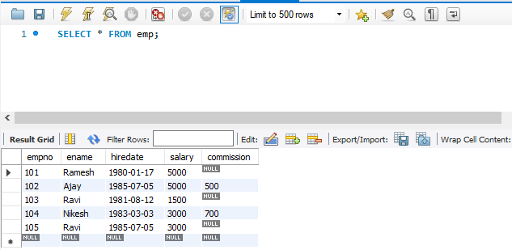

2.Add check constraint (Salary >=5000)

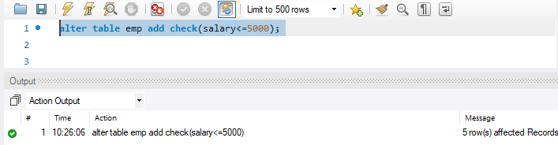

3.Add Check Constraint (length(empno<=3))

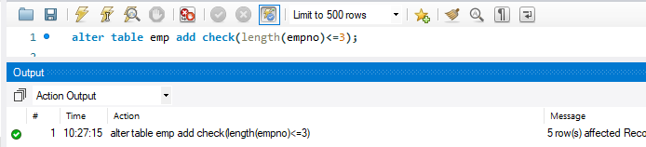

4.Modifying the structure of tables

a.Add new columns: sal number(7,2)

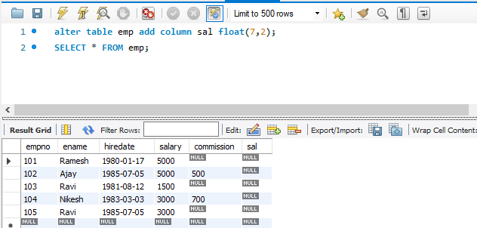

b.Dropping a column from a table: sal

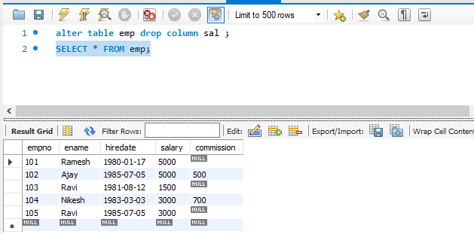

c.Modifying existing column :ename varchar2(15)

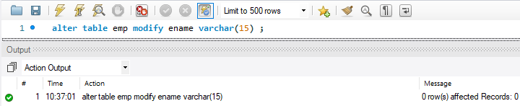

d.Renaming the tables: emp to emp1

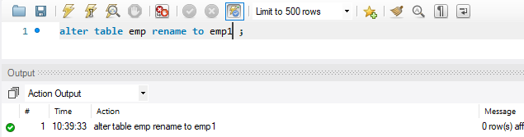

e.truncating the tables:emp1

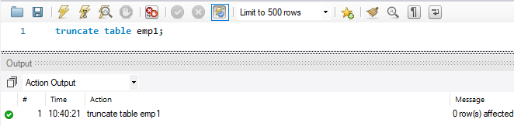

f.Destroying tables:emp

